BSAN 450 Assignment 12

1) The data for this example is the monthly bus ridership values for Portland, Oregon, during the period January 1973 to June 1982. The data is in a file named PortlandBusRidership.csv.

a) Read the data into R Studio. Plot the data and the ACF for the data or the appropriate differences of the data to determine what transformations of the data are necessary to achieve a stationary time series.

b) Postulate an ARIMA model for this data.

The R commands to read the data into R Studio, plot the data or differences, and plot the ACF are given below. (Note the command win.graph will produce a more appropriate plot. If this window is closed, the plot window will revert to the default value. If you want to return to the window with the longer plot size you need to execute this command again.)

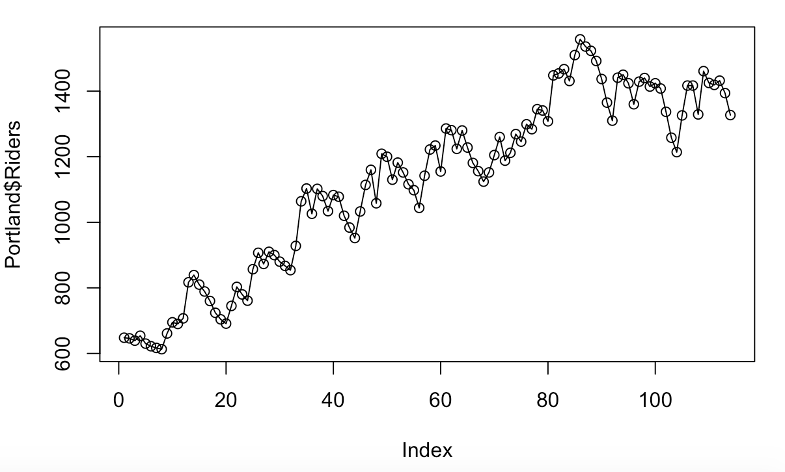 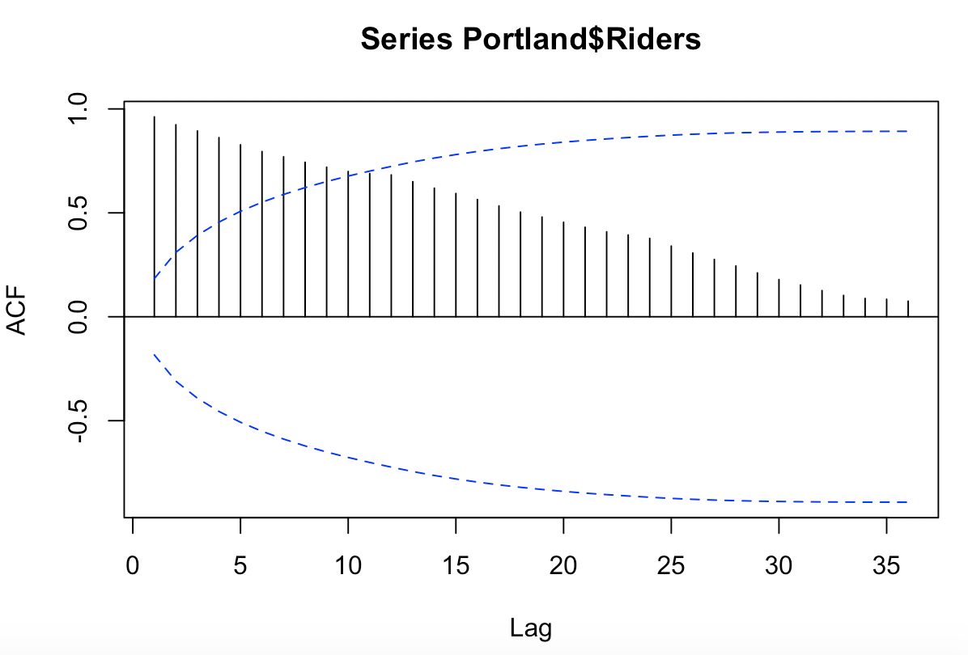

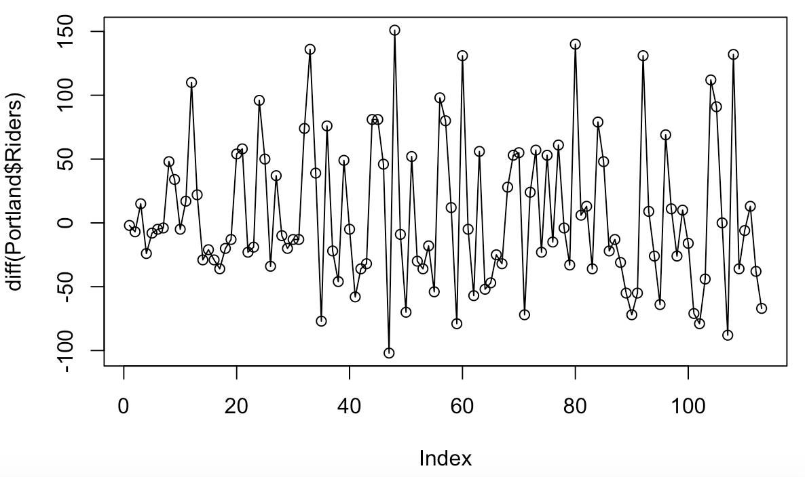 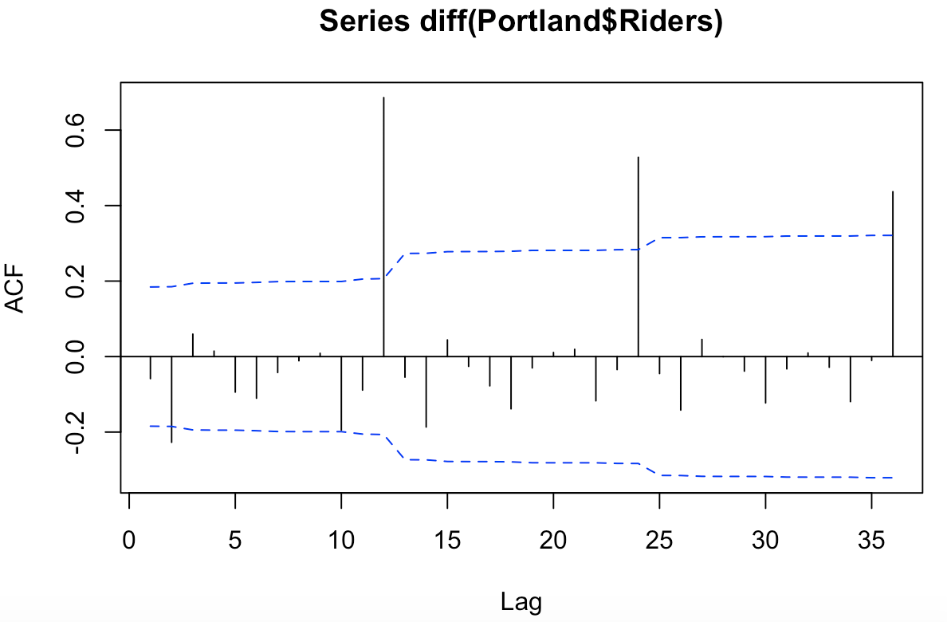

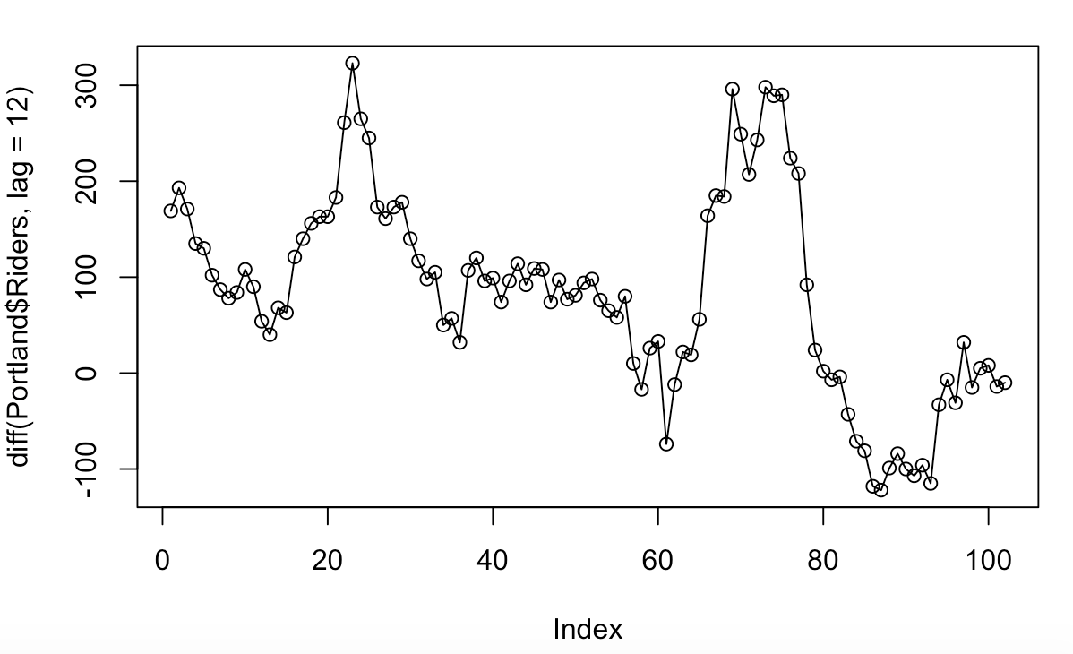 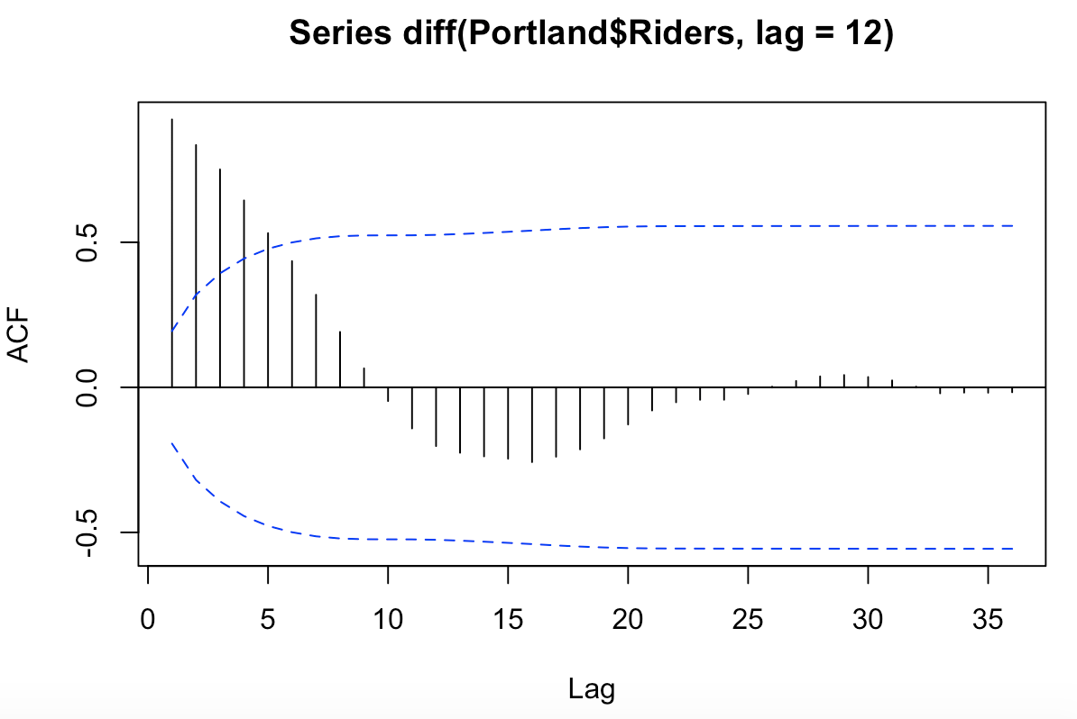

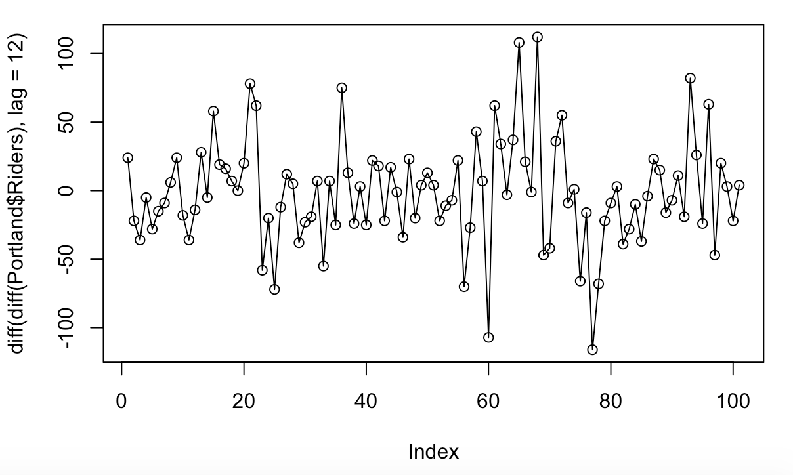 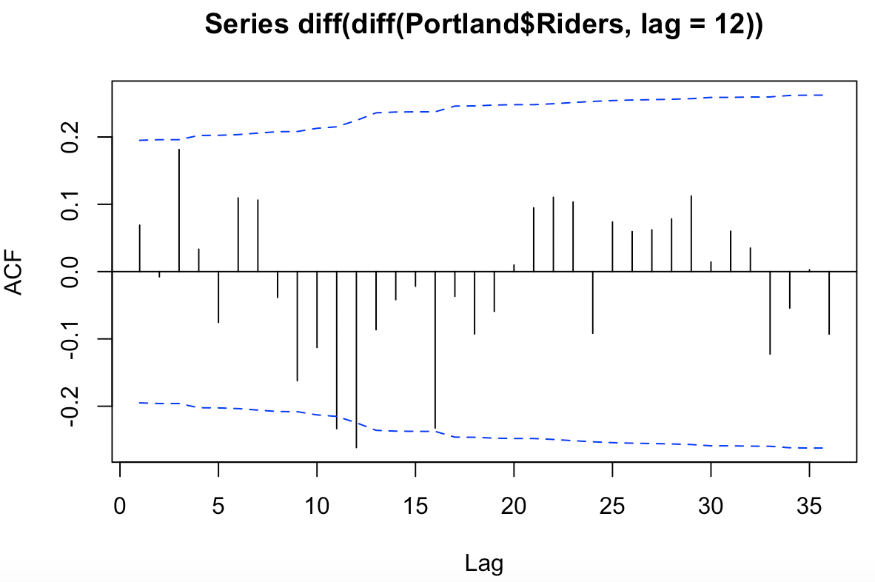

c) Estimate the model you postulated in part b. Check the residuals for this model.

The following are the R commands you may need to modify these commands to specify the model that you want to fit. In the Box.test command the fitdr=1 may need to be modified. The value needs to be the number of parameters that you fit in your model.

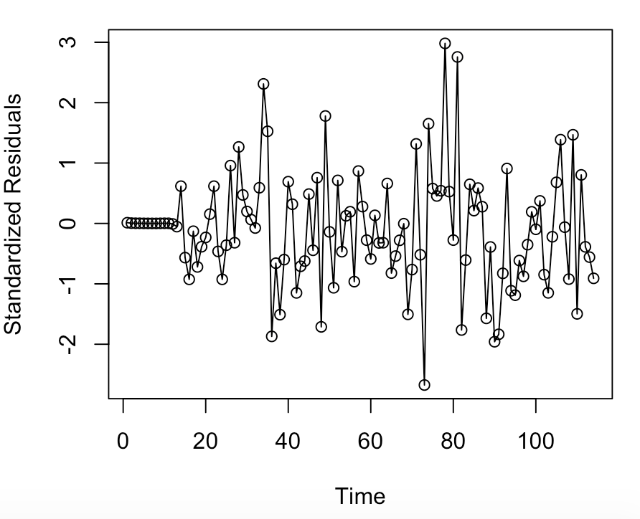 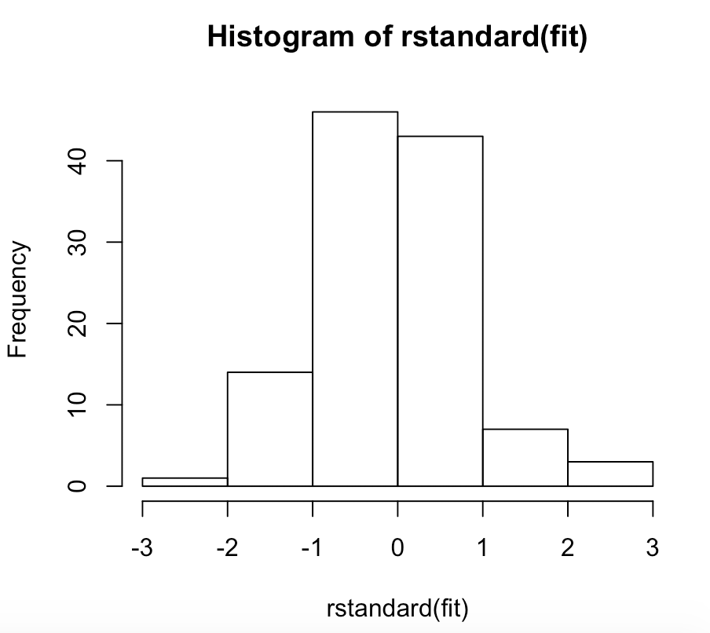

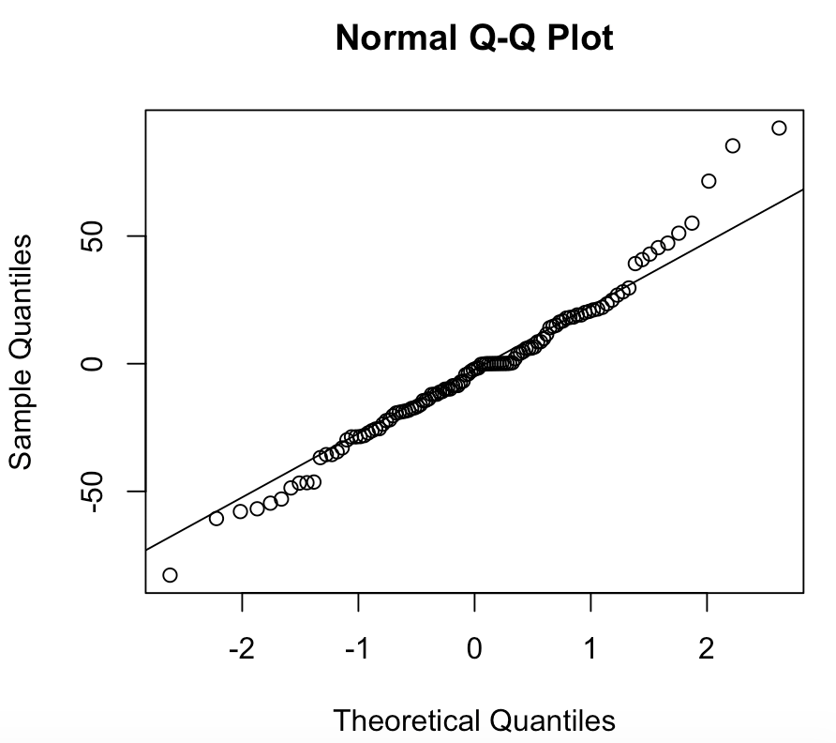 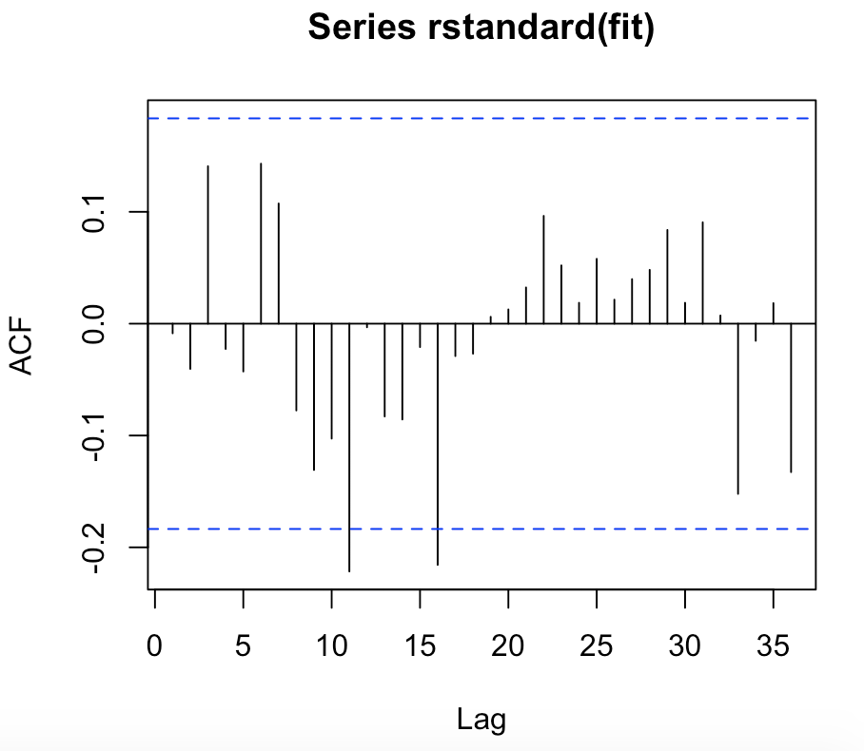

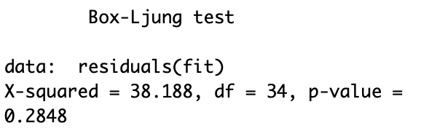

**The diagnostics do not indicate any issues with this model: SMA(2)**

d) If there are any problems with you model, try to modify the model to address these problems.

e) Compute and plot the forecasts for the next 24 months for the model you developed.

The R commands to compute and plot the forecasts follow. Note that fit is the name of the model.

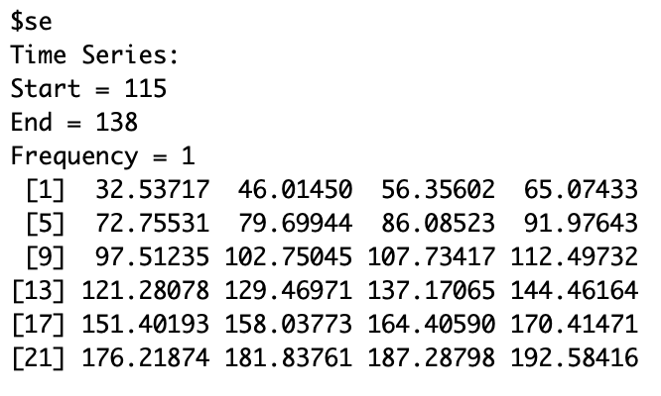 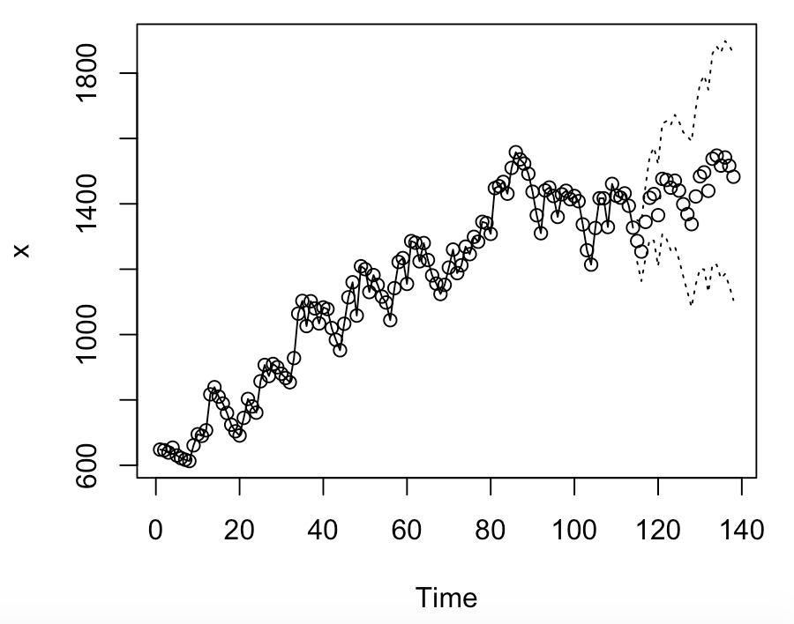

2) The data for this example is the monthly number of housing starts in the U. S. from January 2000 to December 2013. The data are in a file named Starts.csv and the name of the variable in this file is Starts.

a) Read the data into R Studio and plot the data and various differences. Use the following commands to read the data into R Studio. The command to plot the data is given. You need to also plot the first difference of the data, the twelfth difference of the data and the first and twelfth difference of the data.

library(TSA)

hs=read.csv("Starts.csv")

win.graph(width=6.875, height = 3.5,pointsize=8)

plot(hs$Starts,type='o')

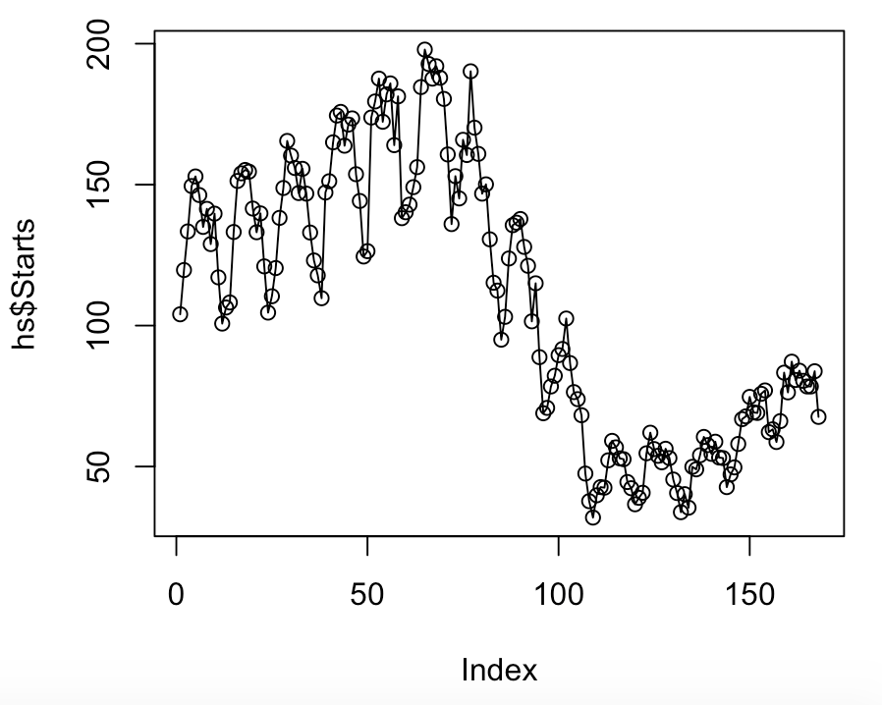 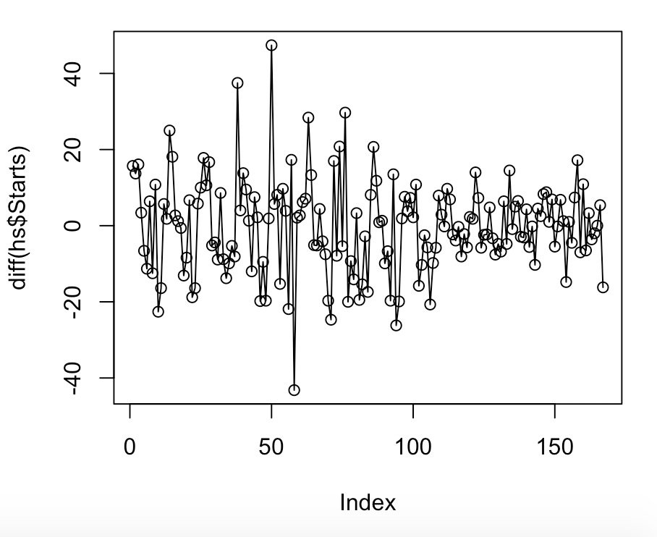

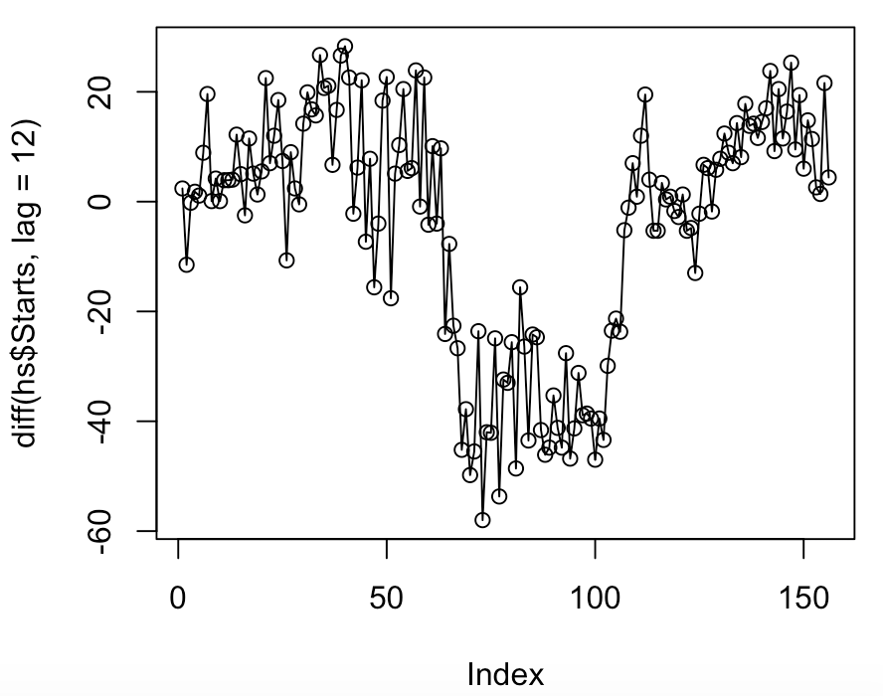 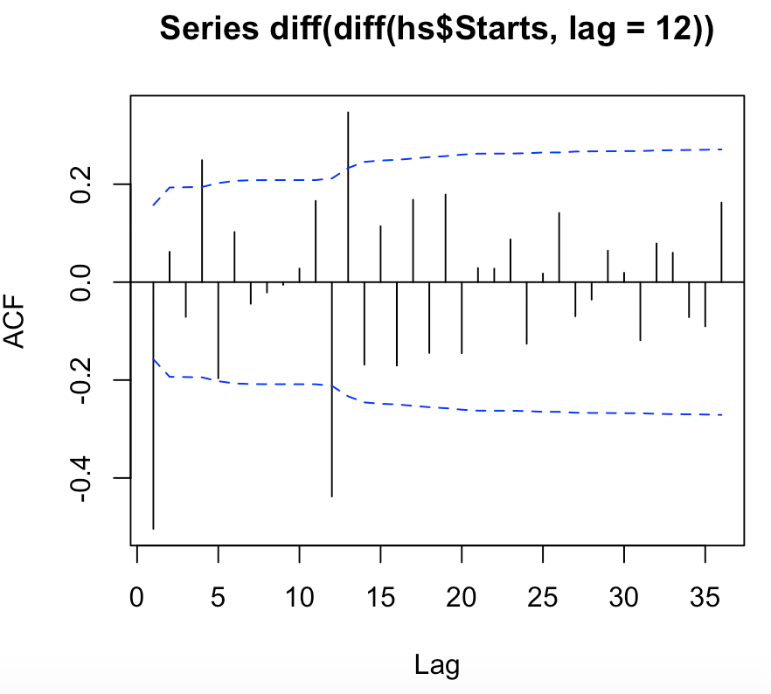

b) It might be a good idea to consider a non-linear transformation of the data. Execute the following R command which creates a Box-Cox plot for time series data. What does this indicate about transforming the data?

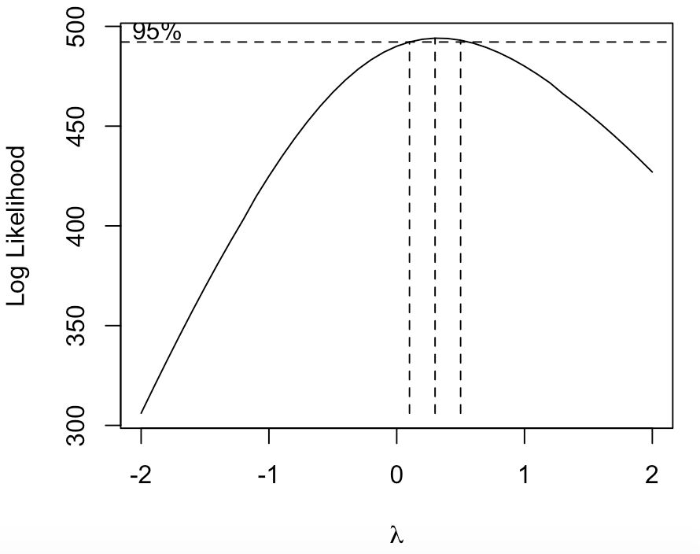

**This indicates that a log transformation would be best.**

c) Transform the time series by taking the logs. Plot the time series of the log data and differences of the log data. Plot the ACF of the log data and differences of the log data. Suggest a model for the log data.

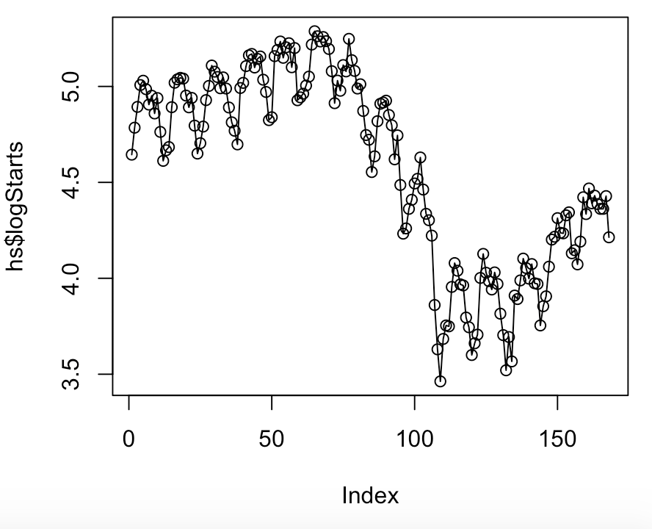 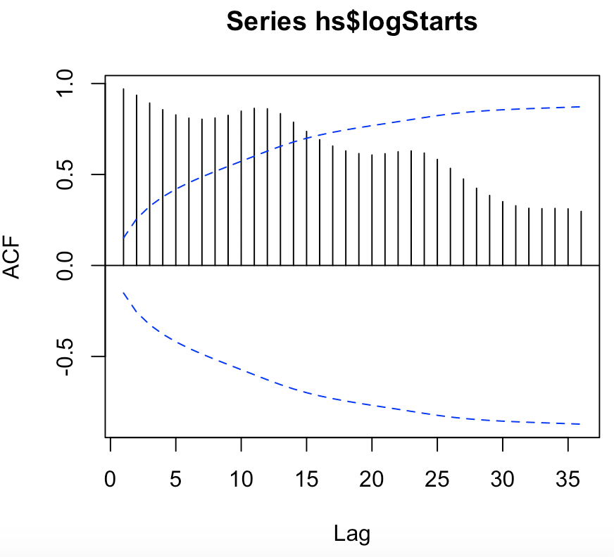

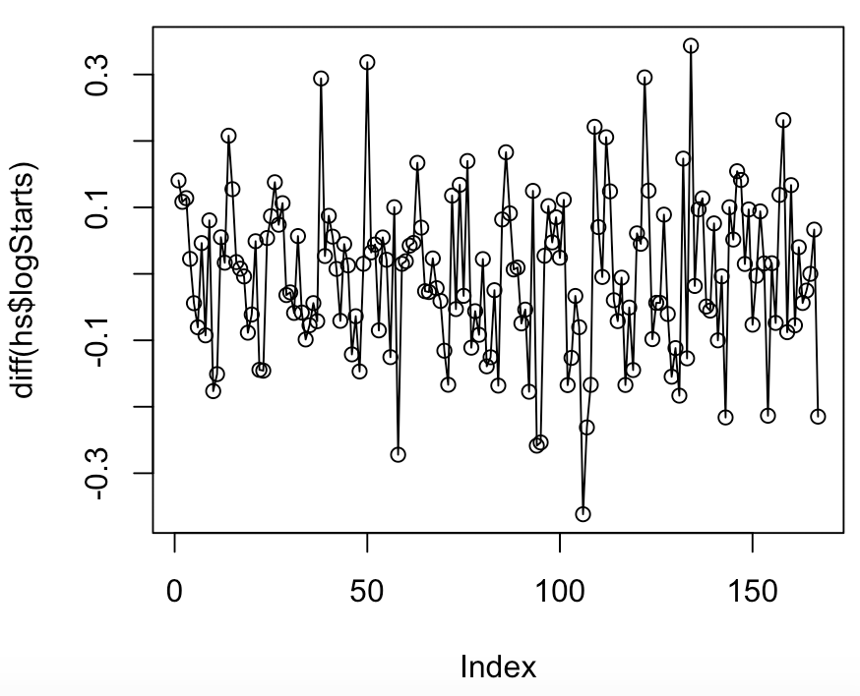 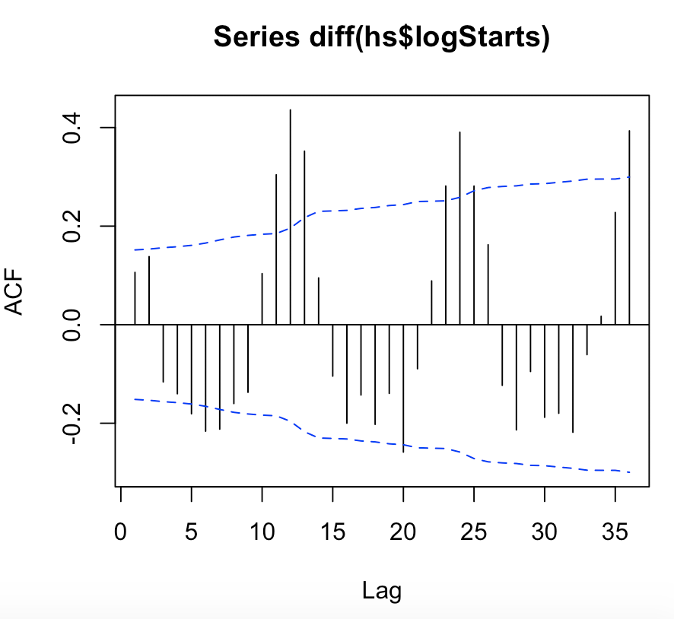

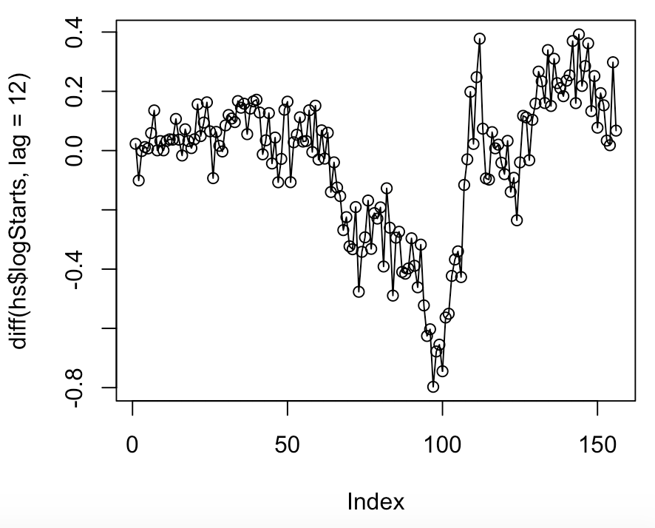 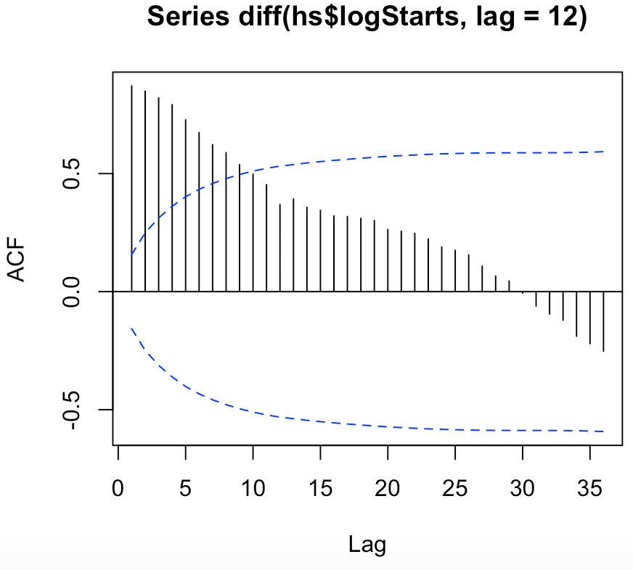

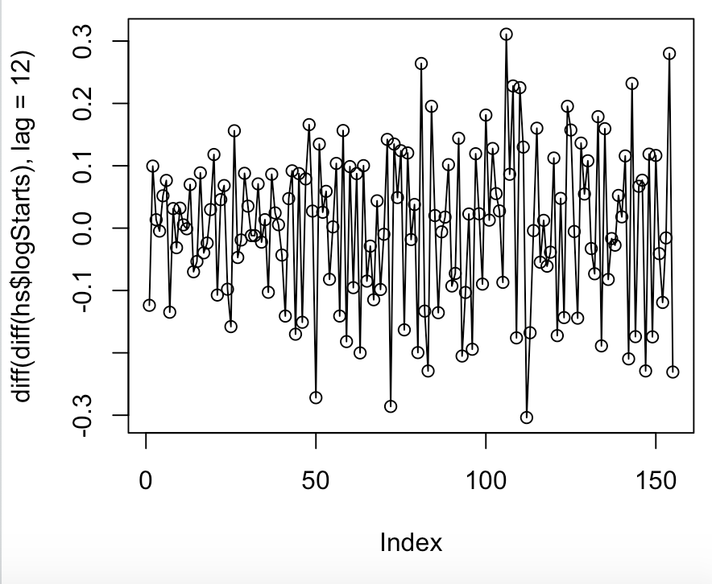 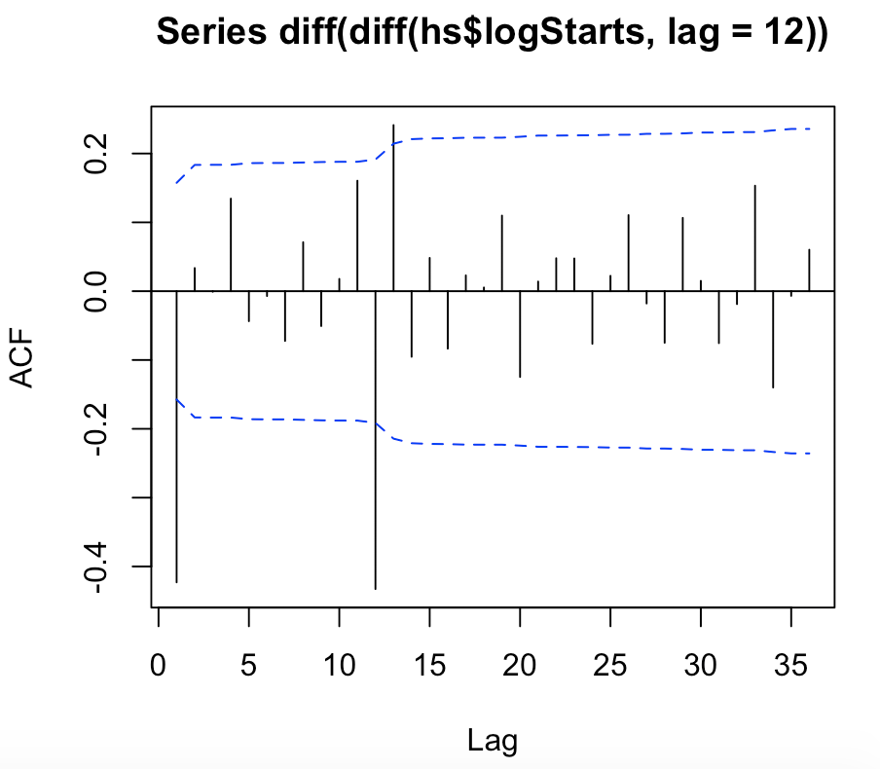

ARIMA model : MA(1)*SMA(1)

d) Fit the model you identified in part c). Perform the diagnostic checks for this model. Is there any indication of a problem with this model?

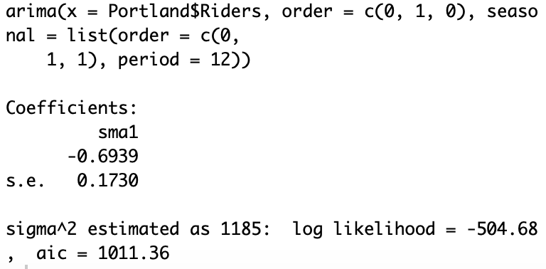 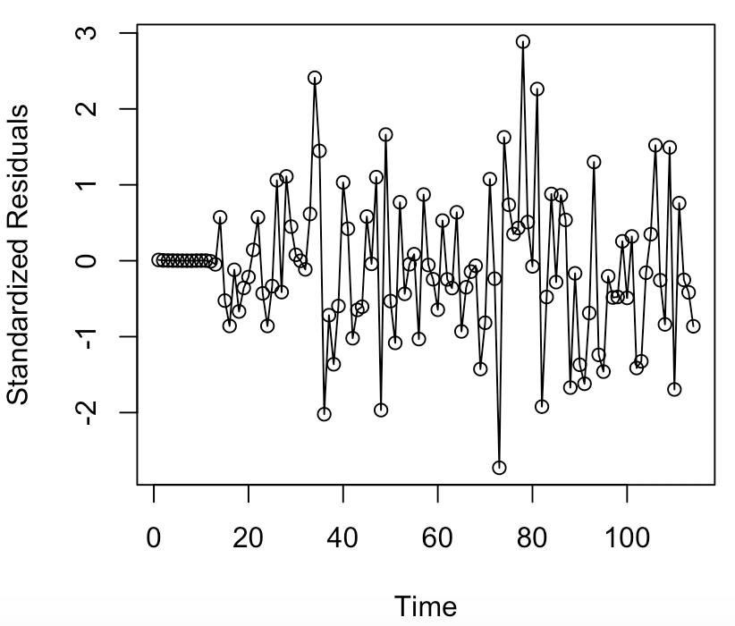 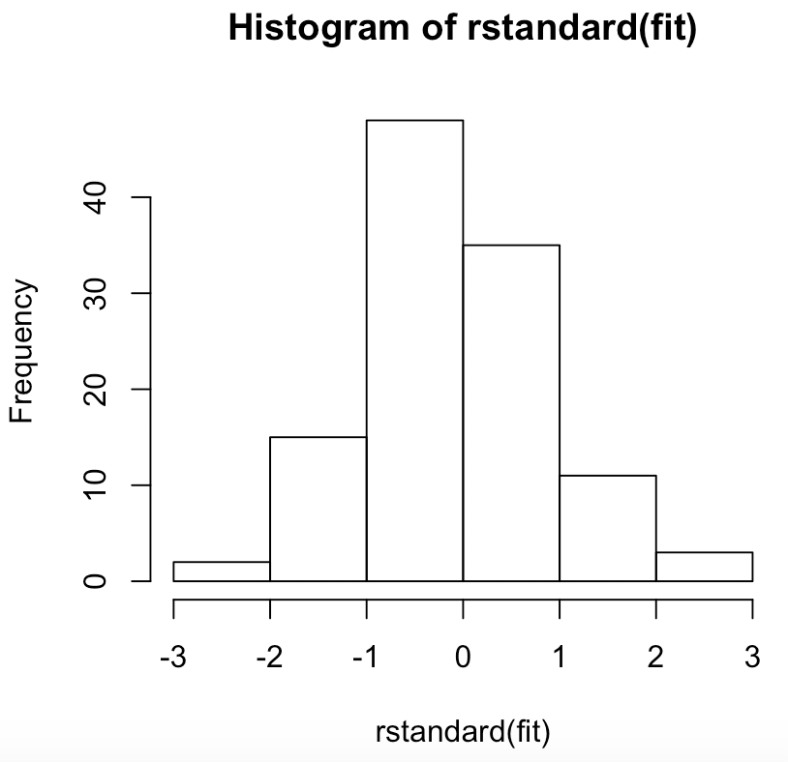

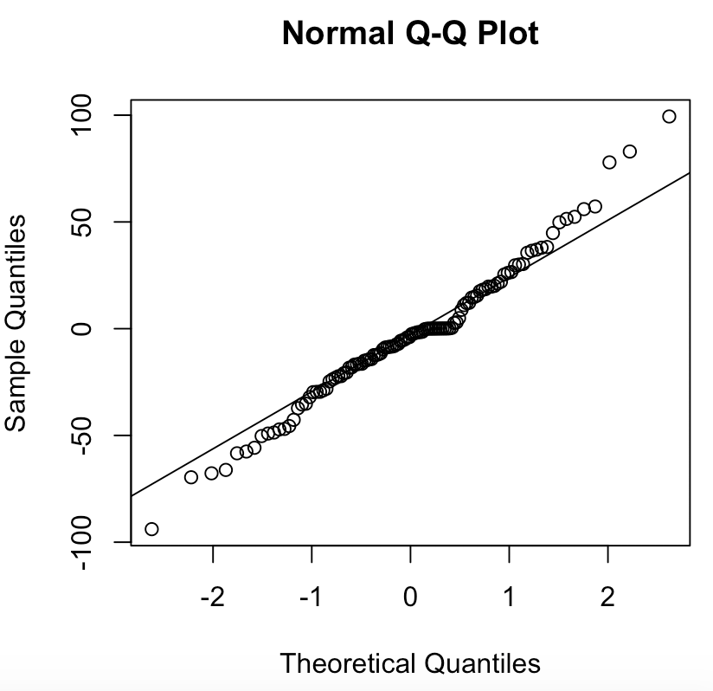 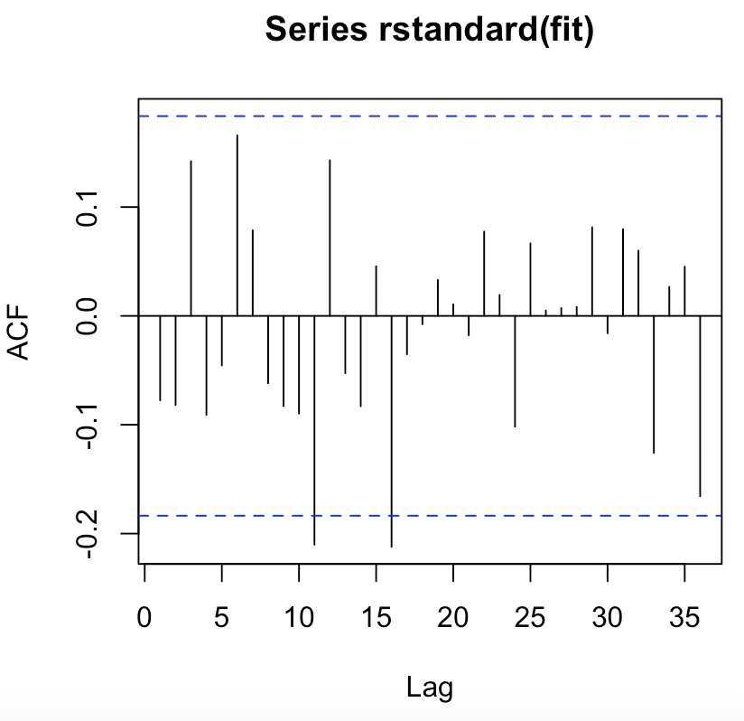

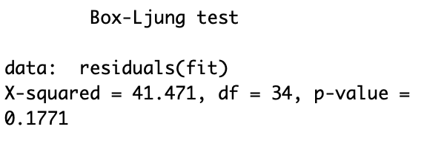

**The diagnostics of the model do not indicate any issues.**

e) Using the model for the log data predict the value of the log housing starts for the next 24 months. Plot these values. If the name of your model is “fit” the commands to do this are below.

